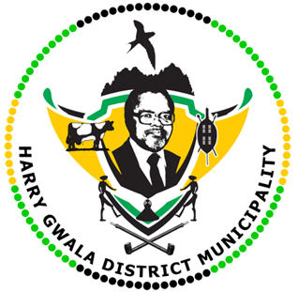
HARRY GWALA DISTRICT MUNICIPALITY
“Together We Deliver and Grow”
OFFICE OF THE MUNICIPAL MANAGER
40 Main Street, Private Bag X501, IXOPO 3276
Tel: (039) 834 8700 Fax: (039) 834 1701
Email: NgubaneN1@harrygwaladm.gov.za

01 MAY 2023
Workers’ Day Message by His Worship the Mayor of the Harry Gwala District Municipality, Cllr ZD Nxumalo.
Workers are a vital aspect of any organisation that seeks to make a positive mark in its targeted customers. In the context of our sphere of government, workers are the implementers of the vision, mission, and requests of our communities, who are our customers, as guided by the relevant legislations, including the Constitution of the Republic of South Africa, the Municipality Systems Act and the Municipal Finance Management Act.
Workers’ Day has been officially recognised and observed as an important day to be commemorated in our country since the first democratic elections in 1994. Moreover, the day serves as a celebration of workers’ rights, celebration of fair employment standards and as a reminder of the key role that trade unions played in the fight against Apartheid.
On this Workers’ Day, which is celebrated on the 1st of May of each year, I, on behalf of the Harry Gwala District Municipality, wish to applaud and commend the workers of our institution led by the Municipal Manager, Mr. Gamakulu Ma-Art Sineke for working to realize the wishes of our communities, often times, going over and beyond the call of duty. Your commitment to changing the lives of the people is evident and commendable. Keep up the good work.
Happy Workers Day to the employees of the Harry Gwala District Municipality.
ISSUED BY HARRY GWALA DISTRICT MUNICIPALITY COMMUNICATIONS UNIT.
039 834 8700

